**White Gaussian Noise Generator**

close all % close all plots

clear all % clear all variables

clc % clear the screen

**Generation of the sinusoid and plot**

The following code segment generated sinusoidal signal with parameters defined below and plotting.

%% generation of the sinusiod and plot

A=1; % Amplitude of the sinusoid [V]

f0=1000; % frequency of the sinusoid

fs=20000; % sampling frequency

duration=0.05; % singal duration in seconds

[t,x,N]=SinusoidalSource2023(A,f0,duration,fs); % generation of the singal

plot(t,x,'r')

xlabel('t [s]')

ylabel('x(t) [V]')

title('Original signal x(t)')

axis([min(t) max(t) 1.2*min(x) 1.2*max(x)])



The original signal is a sinusoidal waveform with an Amplitude of 1V, frequency of 1000hz and duration is 0.05seconds.

signal_power=0.5*A^2;

fprintf('sinusoid power [V^2]=%f' , signal_power)

sinusoid power [V^2]=0.500000

figure

PlotSpectrum(x,fs);

title('Spectrum of the signal');



The picture above shows the the spectrum of the signal, which represents the power distribution in the frequency domain. The two peaks are more than -30dB and symmetrical around the 0 frequency at 1kHz and -1kHz.

**Noise Generation**

The following code segment generated a Gaussian noise signal with the parameter defined below and added to the original sinusoidal signal. The power of noise and SNR is calculated. Finally, the original signal and the noisy signal are compared. The following expression is the probability density function (PDF) of a Gaussian distribution with a zero mean and variance σ^2.

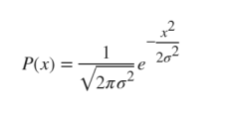

%% Noise generation

sigma=0.6; % std deviation of the noise. The noise power is sigma ^2 [v^2]

noise=sigma*randn(1,N); % generation the noise

fprintf('Noise power[V^2]=%f', sigma^2)

Noise power[V^2]=0.360000

x_noisy=x+noise; % add Gussian noise to sinusoid

signal_to_noise_ratio_dB=10*log10(signal_power/(sigma^2));

fprintf('SNR [dB]=%f',signal_to_noise_ratio_dB)

SNR [dB]=1.426675

figure

plot(t,x_noisy,'k')

hold on

plot(t,x,'r')

legend('x(t)+noise','x(t)')

title('Signals');

xlim([0.0043 0.0456])

ylim([-2.32 2.64])

xt = findobj(gcf, "DisplayName", "x(t)")

xt =

Line (x(t)) with properties:

Color: [1 0 0]

LineStyle: '-'

LineWidth: 0.5000

Marker: 'none'

MarkerSize: 6

MarkerFaceColor: 'none'

XData: [0 5.0000e-05 1.0000e-04 1.5000e-04 2.0000e-04 2.5000e-04 3.0000e-04 3.5000e-04 4.0000e-04 4.5000e-04 5.0000e-04 5.5000e-04 6.0000e-04 6.5000e-04 7.0000e-04 7.5000e-04 8.0000e-04 8.5000e-04 9.0000e-04 9.5000e-04 … ] (1×1001 double)

YData: [1 0.9511 0.8090 0.5878 0.3090 6.1232e-17 -0.3090 -0.5878 -0.8090 -0.9511 -1 -0.9511 -0.8090 -0.5878 -0.3090 -1.8370e-16 0.3090 0.5878 0.8090 0.9511 1 0.9511 0.8090 0.5878 0.3090 3.0616e-16 -0.3090 -0.5878 -0.8090 … ] (1×1001 double)

Show all properties

datatip(xt,0.0218,0.309);



The original signal and noisy signal are plotted in one picture. In general, this picture shows that noisy signal amplitude is between 1.6 and 0.4 which is the amplitude plus sigma and amplitude minus sigma, the noise only affects amplitude, because of the AWGN feture: Additive, White, zero mean, Gaussian, stationary and uncorrelated.

figure

PlotSpectrum(x_noisy,fs);

title('Spectrum of the singnal+noise before filting');



The picture shows above illustrated the spectrum of the signal with noise. Comparing to the spectrum of the signal without noise, it can be found that the power is uniformly distributed in the spectrum except at 1000 Hz and -1000 Hz. The power at each single frequency is a random value.

**FIR Filter**

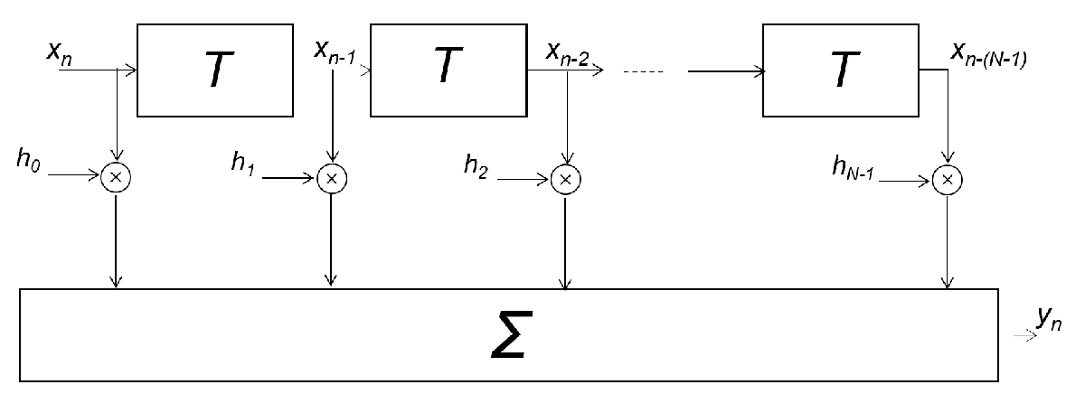

This is a digital filter used to process signals by convolution operation. The input signal is convolved with a filter coefficient.

Nf=400; % Number of FIR filter taps

**Low pass filter design**

The following code segment generated a low pass filter with a 3dB cut off frequency Fpass is set to 2000 hz.

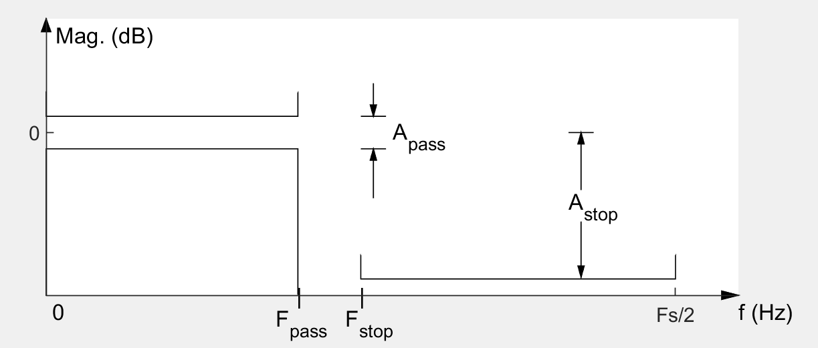

%% *Low pass filter design *

Fpass=2000; % 3dB cut frequency

h_lowpass=fir1(Nf, Fpass/(0.5*fs)); % filter design

%% *Filter impluse response and frequency respond (transfer function)*

stem(h_lowpass) %filter taps (coefficients), that is ,filter impluse resopnse

title('Low pass filter: impluse response')



This picture shows the impulse response of the low pass filter, in the time domain, it is a sinc function.

freqz(h_lowpass,1,[],fs); % plot the frequency response

title('Low pass filter: frequency response')



This plot show the magnitude response and phase response of low-pass filter. It allows low frequency pass it with no attenuation and linear phase response, and block the high frequency. The filter allows signals below Fpass=2000Hz to pass through truncating signals above 2000Hz. In phase and frequency, signals below 2000hz are linear which do not do not change the original information.

**Passband filter design**

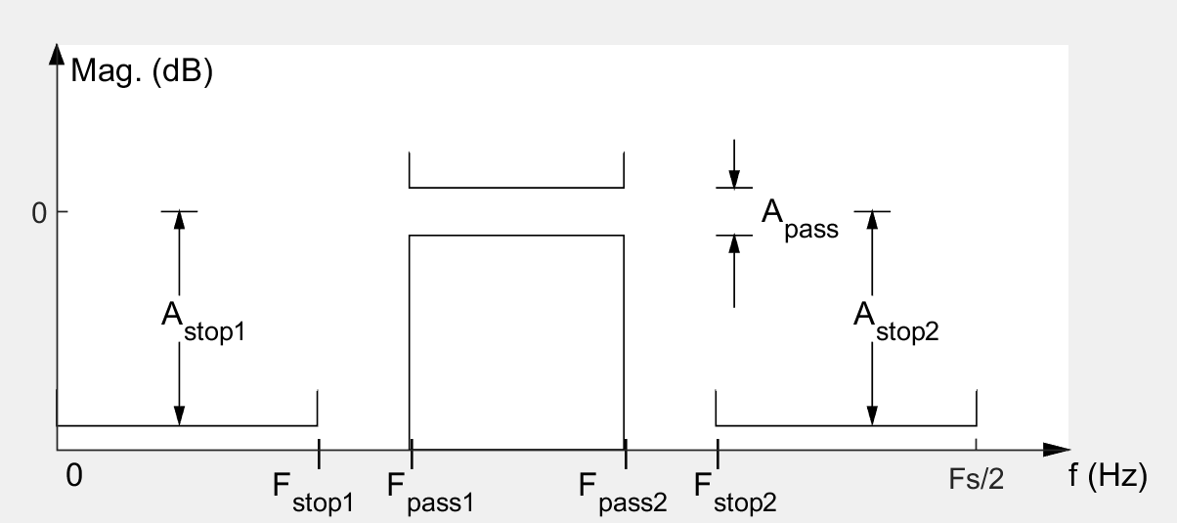

This is a band pass filter, which allows signals with frequency in pass band to pass through. The following code segment generated a band pass filter with passband between 800hz-1200hz.

%% *Passband filter design*

Fpass1=800; % low cut frequency of the filter

Fpass2=1200; % hign cut frequenct of the filter

h_bandpass=fir1(Nf, [Fpass1/(0.5*fs) Fpass2/(0.5*fs)],'bandpass');% filer design

%% *filter impluse response and frequency response (transfer function)*

stem(h_bandpass) % filter taps (coefficients), that is, filter impulse response

title('Bandpass filter: impulse response')



freqz(h_bandpass,1,[],fs); %plot the frequency resionse

title('Bandpass filter: frequency response')



By replacing the low pass filter with a bandpass filter, it can be concluded that in the pass band the signal will pass, and signals below the pass band or above will be truncated. Similar to the low pass filter the effect of the filter on the phase of signals is also linear.

**Filtering**

The filtering process is a convolution of signal and impulse response of filter.

%% *Filtering*

y=conv(x_noisy,h_bandpass,'same'); % filter the singal with the bandpass filter

%y=conv(x_noise,h_lowpass,'same'); % filter the singal with the lowpass filter

%% *Plots*

figure

PlotSpectrum(y,fs);

title('Spercrum of the singal after filtering');



It can be concluded that after passing the filter, most of the signal energy is concentrated in the passband, and energy outside the passband is suppressed by filter.

figure

plot(t,x,'r')

hold on

plot(t,y,'b')

xlabel('t [s]')

legend('x(t):original sinusiod','y(t):outputof the filter')

title('Signals');



Comparing the signal passing through the filter and the original signal, their waveform are basically similar and do not affect the extraction of information.

figure

plot(t,y,'b')

hold on

plot(t,x_noisy,'k')

xlabel('t [s]')

legend('y(t): output of the filter','x(t)+noise :input of the filter')

title('Signals')



Filters can effectively filter out clutter and improve signal quality.

**the outputs of the lowpass filte**

figure

PlotSpectrum(y,fs);

title('Spectrum of the signal after filtering')



figure

plot(t,x,"r")

hold on

plot(t,y,'b')

xlabel('t [s]')

legend ('x(t): original sinusoid','y(t): output of the filter')

title('Signals');



From the picture above, We can get the information that the output signals of the filter are slightly different from the original signals in amplitude, however, they are in the same shape pulse, phase, and frequency. In other words, the output signals of the filter have the same information with the original signal. Hence, the filter is a good technology to get the target frequency band signal.

figure

plot(t,y,'b')

hold on

plot(t,x_noisy,'k')

xlabel('t [s]')

legend ('y(t): output of the filter bandpass','x(t)+noise: input of the filter')

title('Signals');



**Compare the outputs for different powers of the sine wave**

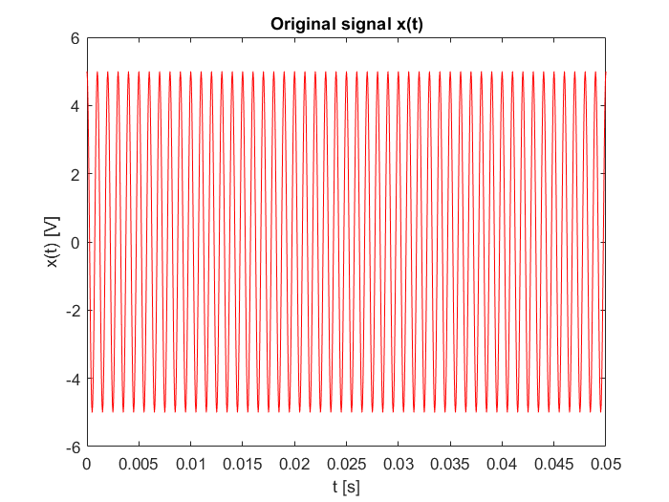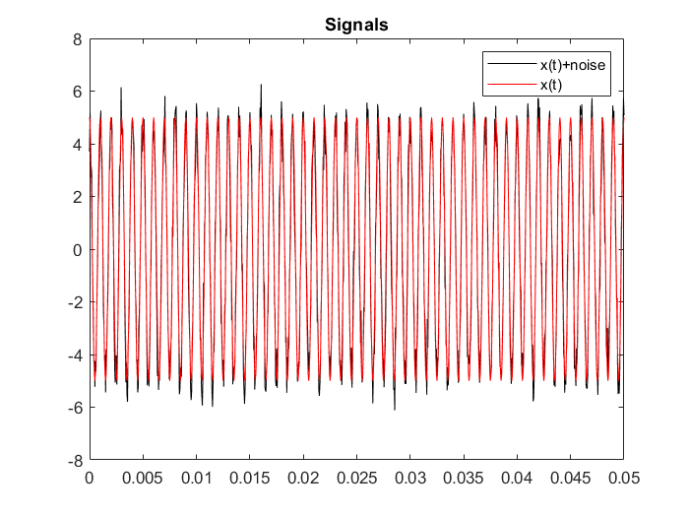



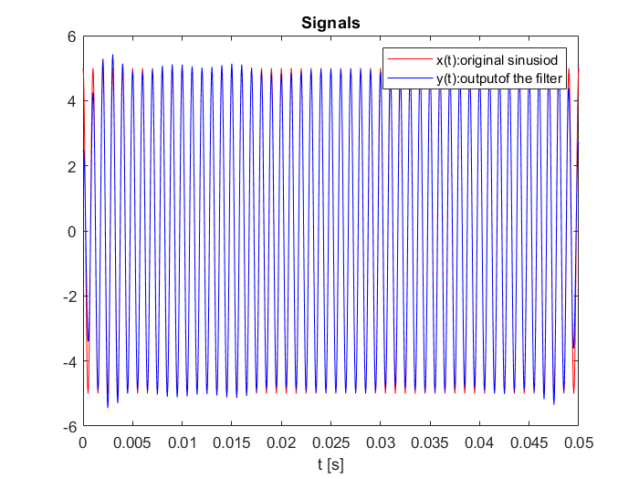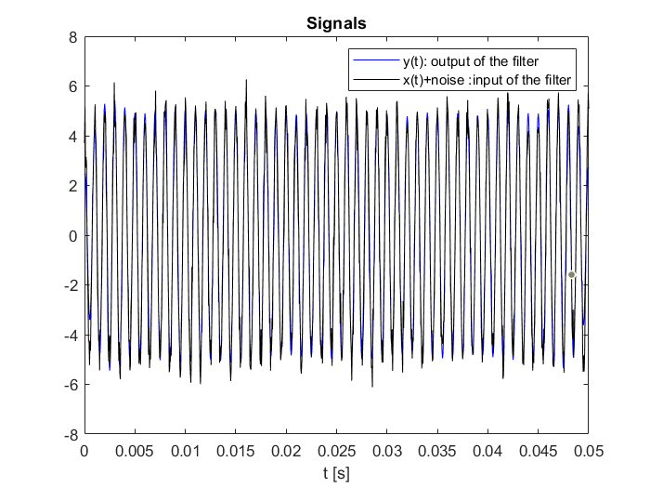



Comparing the outputs for different powers of the sine wave, it can be concluded that changing the amplitude does not have effect on the quality of signals. They have the same shape frequency and phase. The function of the filter does not affect the amplitude. At first, the A is 1, and standard deviation is 0.6, and the SNR is 1.4267, then we set the A is 5 with an unchanged standard deviation, the SNR is 15.41Db.

**increase the standard deviation**

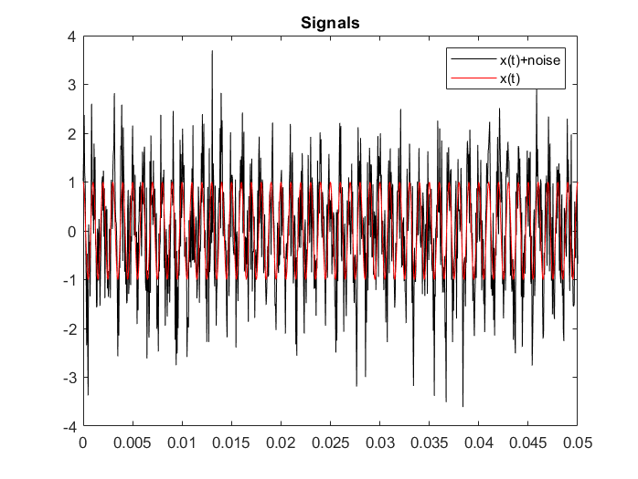

These two plots show that the original signals wave and signals wave with noise in amplitude. In the first picture, we set the standard deviation at 0.6, the peak value of signals with noise is 2.5V, and the valley value is around -2.4V. In the second picture, the standard deviation is 0.9, the peak value is up to around 3.8V, and the valley value is -3.5V. However, in general, the mean value is unchanged. When the noise standard deviation increased, the SNR decreased.

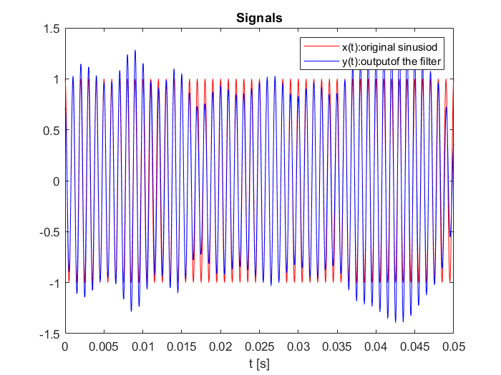

We can draw the conclusion that the increasing noise results in a bad performance in SNR. It does not change the signals' waveform, it affects the amplitude. In general, this influence is acceptable.

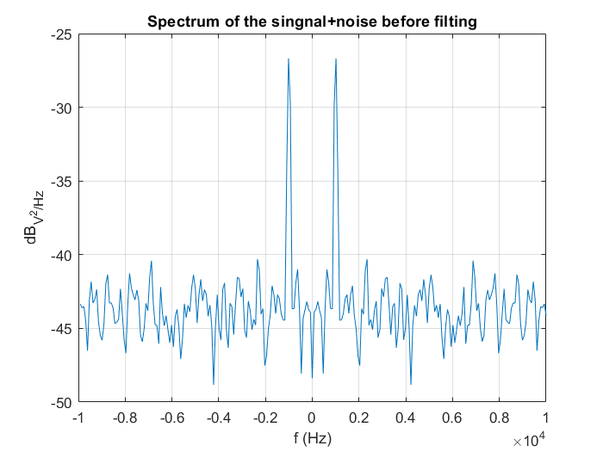

The standard deviation of the first picture is 0.6, and The standard deviation of the second picture is 0.9.

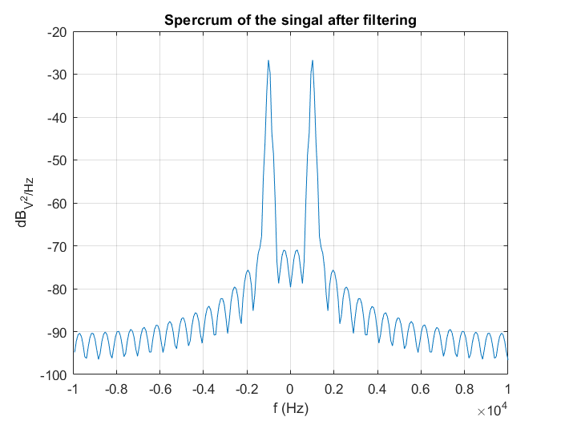

The standard deviation of the first picture is 0.6, and The standard deviation of the second picture is 0.9.

Increasing the deviation does not affect the signal spectrum.

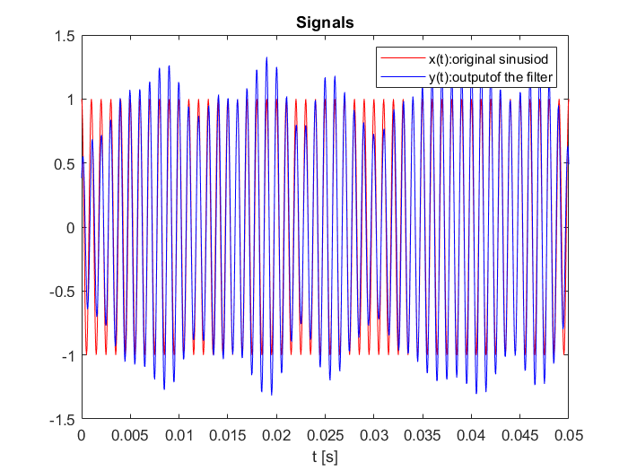

The standard deviation of the first picture is 0.6, and The standard deviation of the second picture is 0.9.

**choose a frequency that does not fall within the filter's passband and observe the outputs.**

Set carrier frequency at 300Hz, the pass band is 800Hz-1200Hz.

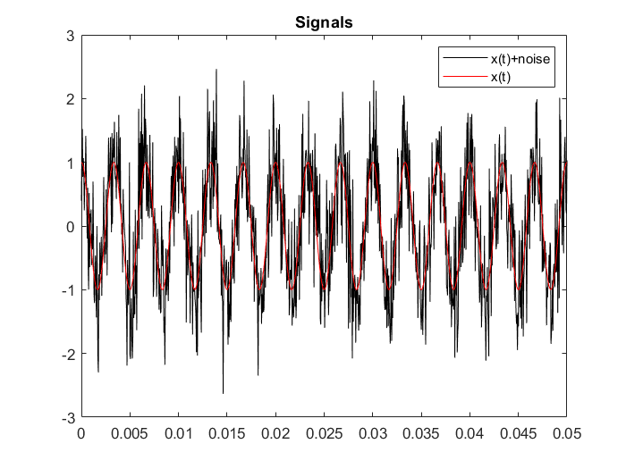

From the picture given above, it can be seen that the carrier frequency became slower than the original one. The signals and the signals with noise basely have the same peak value and valley value.

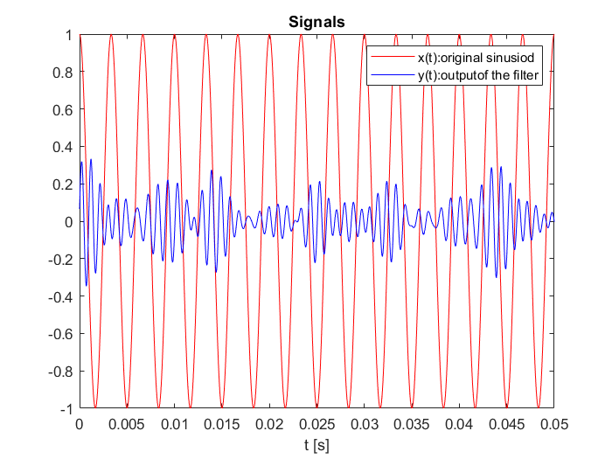

In the first picture, the output signal matches the original signal, meaning the filter allowed most of the 1000 Hz signal to pass through with a slight attenuation and this attenuation can be neglected. The overall shape and frequency of the sinusoid remain consistent. In the second picture, the original sinusoidal signal is at 300 Hz, which is below the passband. The output signal shows significant attenuation compared to the original signal. The original 300 Hz sinusoid is largely suppressed by the filter. The output signal has a much smaller amplitude and appears heavily distorted. When the input signal frequency is within the passband,1000 Hz in the first plot, the lowpass filter allows the signal to pass through with minimal attenuation. However, when the signal frequency is outside the passband,300 Hz in the second plot, the filter heavily attenuates the signal, resulting in a much weaker and distorted output.